Figure 7.5.1: Shipping cost calculator.

import java.util.Scanner;

public class ShippingCost {
// Determine shipping tax on cost
public static double calcTax(double cost) {
return cost * 0.15;
}

// Determine shipping cost based on weight
public static double calcShippingCost(double weight) {
double cost;

if (weight < 1) {
cost = 7.88;
}
else if (weight < 6) {
cost = 14.32;
}
else if (weight < 10) {
cost = 21.11;
}
else{
cost = 25.5;
}
cost = cost + calcTax(cost);

return cost;
}

public static void main(String[] args) {
Scanner scnr = new Scanner(System.in);
double weightOfPackage; // User defined package weight

System.out.print("Enter package weight: ");
weightOfPackage = scnr.nextDouble();
System.out.print("Shipping cost: $");
System.out.printf("%.2f", calcShippingCost(weightOfPackage));
System.out.println("");
}
}

CHALLENGE ACTIVITY. 7.5.2: Method with branch: Popcorn.

Complete method printPopcornTime(), with int parameter bagOunces, and void return type. If bagOunces is less than 2, print "Too small". If greater than 10, print "Too large". Otherwise, compute and print 6 * bagOunces followed by " seconds". End with a newline. Example output for ounces = 7:

42 seconds

Answer:
import java.util.Scanner;

public class PopcornTimer {

public static void printPopcornTime(int bagOunces) {

if (bagOunces < 2) {
System.out.println("Too small");
}
else if (bagOunces > 10) {
System.out.println("Too large");
}
else {
System.out.println((6 * bagOunces) + " seconds");
}

}

public static void main (String [] args) {
Scanner scnr = new Scanner(System.in);
int userOunces;

userOunces = scnr.nextInt();
printPopcornTime(userOunces);
}
}

CHALLENGE ACTIVITY. 7.5.3: Methods with branches

Define a method findUserTax() that takes one integer parameter as the person's age, and returns the person's tax percent as a double. The tax percent is returned as follows:
- If a person's age is more than 80 years old, tax percent is 0.09.
- If a person's age is more than 40 and up to 80 years old, tax percent is 0.27.
- Otherwise, tax percent is 0.43.
Ex: If the input is 85, then the output is:
0.09

Answer:
import java.util.Scanner;

public class TaxFinder {

public static double findUserTax(int userAge) {
if (userAge > 80) {
return 0.09;
}
else if (userAge > 40) {
return 0.27;
}
else {
return 0.43;
}
}

public static void main(String[] args) {
Scanner scnr = new Scanner(System.in);
int userAge;

userAge = scnr.nextInt();

System.out.println(findUserTax(userAge));
}
}

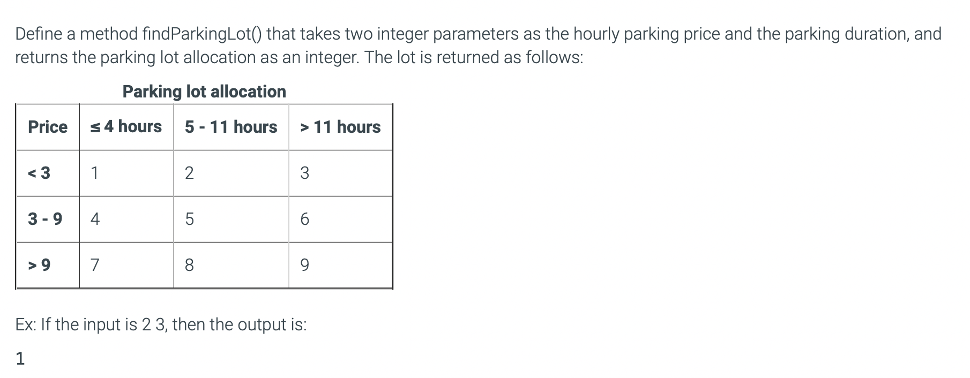

Answer:

import java.util.Scanner;

public class LotFinder {

public static int findParkingLot(int parkingPrice, int parkingDuration) {
int parkingLot;

if (parkingPrice < 3) {
if (parkingDuration <= 4) {
parkingLot = 1;
}
else if (parkingDuration <= 11) {
parkingLot = 2;
}
else {
parkingLot = 3;
}
}
else if (parkingPrice <= 9) {
if (parkingDuration <= 4) {
parkingLot = 4;
}
else if (parkingDuration <= 11) {
parkingLot = 5;
}
else {
parkingLot = 6;
}
}
else {
if (parkingDuration <= 4) {
parkingLot = 7;
}
else if (parkingDuration <= 11) {
parkingLot = 8;
}
else {
parkingLot = 9;
}
}
return parkingLot;
}

public static void main(String[] args) {
Scanner scnr = new Scanner(System.in);
int parkingPrice;
int parkingDuration;

parkingPrice = scnr.nextInt();
parkingDuration = scnr.nextInt();

System.out.println(findParkingLot(parkingPrice, parkingDuration));
}
}

